A decade of movement ecology

## Abstract (250 words - I’m at 286 now)

Movement is life. It affects population dynamics, biodiversity, and consequently, the structure of ecosystems. With the recent development of sophisticated tracking technology, software and analyses, research in movement ecology has significantly increased in the last decade. This work provides a synthetic and quantitative review of the scientific literature in movement ecology, since the seminal work of Nathan et al (2008), which formally introduced the movement ecology framework. We reviewed 5354 peer-reviewed papers in movement ecology published in the last decade. With a text mining approach, we assessed the number of papers which have attempted to investigate core components of the movement ecology framework—that is, motion, navigation, internal state and external factors—as well as the biologging devices used, the focal taxon, the analytical methods applied and the software used. The changes in the devices and software used reflect an increasing access to finer spatio-temporal data about movement, with increasing ability to process them. However, this is not reflected in the choice of statistical methods which are mostly general rather than movement related. Even more importantly, and just like ten years ago, studies rarely focus on the components of the movement ecology framework (except for external factors). The research topics identified in the literature were organized around questions that corresponded to a mix between understanding theoretical movement processes, data collection and analysis, and practical applications. Based on these findings, we discuss how data and technology have been driving our science, research questions that have not been given enough consideration, and the necessary trade-off between the theory and technology.

Nathan, R., Getz, W. M., Revilla, E., Holyoak, M., Kadmon, R., Saltz, D., & Smouse, P. E. (2008). A movement ecology framework for unifying organismal movement research. PNAS, 105(49), 19052–19059.

## Keywords (min 3)

movement ecology, technology, text mining, biologging, human movement, …

## The rise of a field called movement ecology (there shouldn’t be a title for the Introduction but I like this one)

Movement is intrinsically linked to life and has been a research subject since ancient times. Technological developments in the recent decades have opened possibilities to observe and collect data on animal and human movement, and to expand our knowledge on their movement and behavior (Thums et al. (2018), Börger (2016), Williams et al. (2019)). In what is considered a seminal work in the field, Nathan et al. (2008) proposed a unifying conceptual framework for movement ecology, composed of four components: external factors (i.e. the set of environment factors that affect movement), internal state (i.e. the inner state affecting motivation and readiness to move), navigation capacity (i.e. the set of traits enabling the individual to orient) and motion capacity (i.e. the set of traits enabling the individual to execute movement). The outcome of the interactions between these four components would be the observed movement path (plus observation errors).

A concurrent study examined movement-related papers (Holyoak et al. (2008)), finding that very few works in the literature addressed the links between these components, with the only exception of external factors with motion capacity (62%). They found that the majority of studies were “simply measuring movement, documenting its ocurrence, or describing how it was influenced by the environment”.

Ten years after PNAS’ special feature on Movement ecology – where Nathan’s and Holyoak’s work were published – the number of studies in the field has increased exponentially (Fig. 1), several special issues related to the field have appeared in different journals, and there is now even a Gordon Research Conference on Movement ecology of animals organized every two years (since 2017). It is a good time [RJ: I’m looking for a synonym to the word kairos in Greek… any ideas?] to reflect on the status of research on this field, and to investigate the role of ideas (e.g. the movement ecology framework or MEF), data and technology in the field, and what challenges await us.

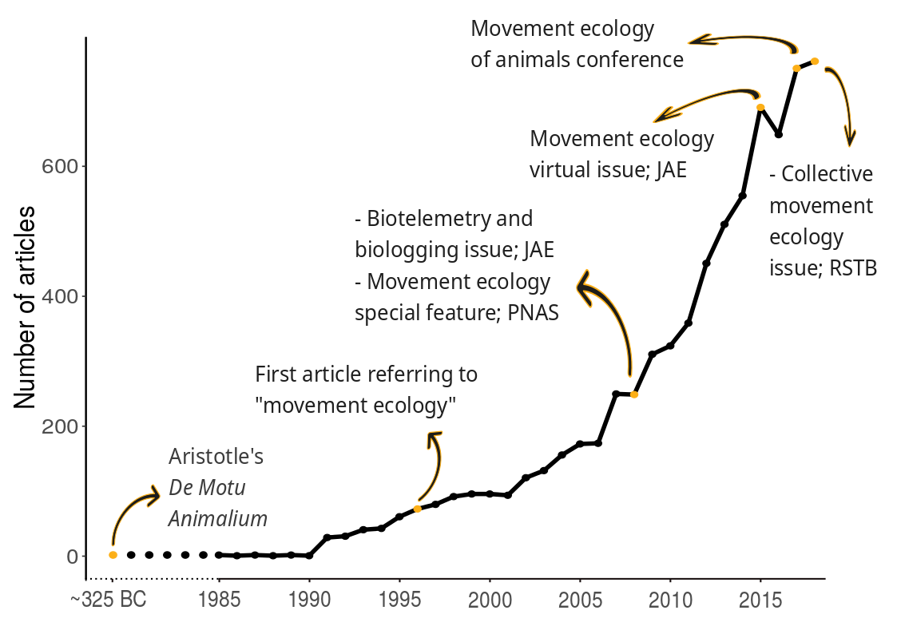{Fig.1. Timeline of movement ecology papers and milestones in the field}

For this purpose, we review the field of movement ecology with a quantitative approach. With a hierarchy of keyword-based filters, we searched the Web of Science for movement ecology papers published in 2009-2018, and analyzed the text in the manuscripts to assess which aspects of movement ecology were being studied and the tools that were being used. All the technical details of the text analysis can be found in Supplementary Materials and the code in R is in [RJ: Zenodo repository].

The document is organized as follows. First, we analyze the framework and quantified the study of its different components. Then, we assess the use of different tools (i.e. biologging devices, software and statistical methods) in the papers. Next, we identify topics and research subjects in which papers were organized. Finally, with all these elements in hand, we provide an integrative view of the field, its strengths, limitations and future directions.

## The movement ecology framework

Most works have addressed the relationship between external factors and movement (77%), and a minority of them have studied the three other components (49%, 26% and 9%, for internal factors, motion and navigation capacity, respectively). The same pattern occurred in the decade before (see Supp. Mat), reflecting that, in the last ten years, movement ecologists have not increased their efforts to understand the processes behind movement. The focus on external factors, and particularly on the environment (Table 1), might be a result of having management and conservation as an ultimate goal from understanding movement (Allen and Singh (2016); Ogburn et al. (2017)).

[Comment 2]: # (RJ: Tommy asked for time series. They are in the Supp. Section. There is not much change in time. I am also putting the framework figures (from each decade) in Supp. but we can take them out if there if you think that they are key in the manuscript.)  
  
[Comment 3]: # (RJ: Mathieu made interesting comments, that I copy here. I prefer if he edits directly in the text, or someone else. "MB: Despite repeated calls to figure out the mechanics of movement, we're essentially still doing descriptive studies, relating space use to the environment. I would think that one essential reason for this is management and conservation. We work with habitats, areas—in fact, not species. So the most important piece for management/conservation is the link to the physical environment, which is really what we're managing/protecting (probably for good and bad reasons). *Fundamental movement ecology* remains a niche.")

It is not only more practical but also easier to observe and collect data from external factors like the environment, other individuals or humans. There are satellite data on environmental features, and animal interaction – in some cases – could be observable, and human pressure could be accounted for if there are data from before and after some kind of impact (e.g. noise or urbanization). Conversely, physiological, behavioral syndrome, biophysical and orientation aspects, among others, may need additional data on body conditions or controlled environments to make tests. From the four components of the MEF, navigation was the least studied. Understanding how animals orient in space, using cues and memory may be one of the most challenging tasks in movement ecology. Although advances have been made (e.g. regarding the use of magnetic and sun compass, or the use of odour by many animal species; Hansson and Akesson (2014)), many challenges remain, like understanding how the information is processed by the brain, or obtaining olfactory or sound landscapes data to test hypotheses in the field.

Studying any of these components and thus understanding the movement process of organisms require integrative and multidisciplinary efforts involving ecologists, biologists, neuroscientists, physicists and statisticians, to cite some examples. Because of satellite data availability, a practical need of multidisciplinarity could be lower for external factors. All of these reasons (interest for conservation, data availability, less need for multidisciplinary work) could explain that the majority of movement ecology studies are related to external factors. This pattern was seen in all animal taxonomical groups, except in humans, for which the studies were more uniformly distributed between external factors, internal state and motion (see Fig. 2). For humans, studies would not respond to practical conservation purposes but rather to health and movement efficiency, which involve internal aspects (e.g. nutrition, heart rate, respiration) and motion (e.g. locomotion and biomechanics). The necessary data is also easier to obtain from humans, since they could be directly interested in improving their health (e.g. patients) and increase their movement power (e.g. sport players).

[Comment 4]: # (RJ: If you disagree with what I wrote or find it confusing, please let me know. And feel free to modify the text and complement it with your ideas. )

|  |  |  |  |  |  |  |  |
| --- | --- | --- | --- | --- | --- | --- | --- |
| External factor | Percentage | Internal factor | Percentage | Motion capacity | Percentage | Navigation capacity | Percentage |
| Environment | 80.7% | Adaptation | 45.9% | Empirical | 50.9% | Orientation | 73.6% |
| Animal interaction | 38.1% | Life-history | 42.2% | Biophysical | 36.3% | Cognitive | 25.5% |
| Anthropogenic | 13.6% | Physiological state | 34.5% | Theoretical | 32.1% | Sensory | 7.6% |
| Other | 3.3% | Behavior | 7.2% |  |  |  |  |
| General | 0.4% | General | 1.6% |  |  |  |  |

Table 1. Categories in which each component of the movement ecology framework is split. The percentages are computed as the number of abstracts referring to the category divided by the number of abstracts concerning the correspondent component, multiplied by 100.

[Comment 5]: # (RJ: Tommy, can you improve the caption of Table 1 explaining the elements that need explanation? Or simply point at the link to the readme. Whatever you think it's best, if you think we should keep this table here.)

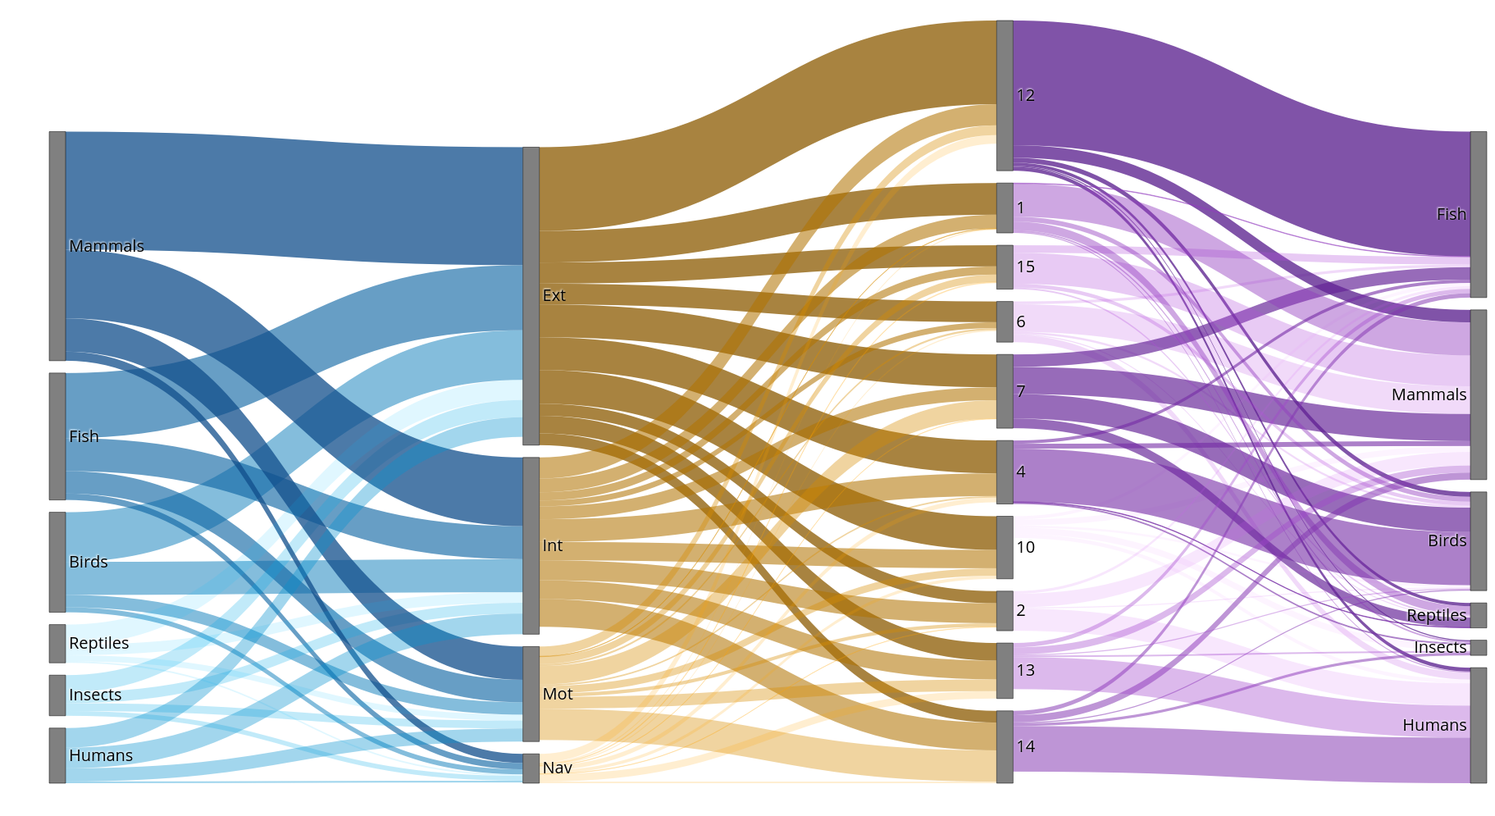{Fig.2. Sankey plot showing the distribution on papers concerning the different taxonomical groups, framework components and main topics. *Humans are considered as a separate group for interpretation.}

[Comment 6]: # (RJ: Matt, can you add a very short explanation of how to read the Sankey plot in the caption?)

## Tools for movement ecology

Technology has been a major driver in movement ecology. Literature reviews highlight a growing trend in the amount and variety of tracking devices, which are becoming more afordable, with more-efficient parametrization for battery saving and shrinking in size (Thums et al. (2018), Kays et al. (2015), Harcourt et al. (2019)). Here we categorized tracking device observations as accelerometer, acoustic telemetry (referred to as “acoustic”), body condition measurements (“body conditions”), encounter observations (“encounter”), GPS, light loggers, pressure data, radar, radio telemetry, satellite and video/image (“video”). Details of these categories and the analysis are in Supp. Mat. Throughout this last decade, GPS has not only remained the most popular device in movement studies, but its use has increased (in proportion to the total number of studies, see Fig. 3). This is likely due to the development of smaller and more efficient devices, which make them a good option for small and medium size animals (Kays et al. (2015)), particularly mammals and birds (see Fig. S10 and S11 in Supp.Mat.). GPS could also be replacing radio telemetry (Allan et al. (2018)), which has been experiencing a decreasing trend. On the other hand, the use of accelerometers and video is becoming more popular in the field, allowing for finer spatio-temporal resolution movement data (Fig. 3).

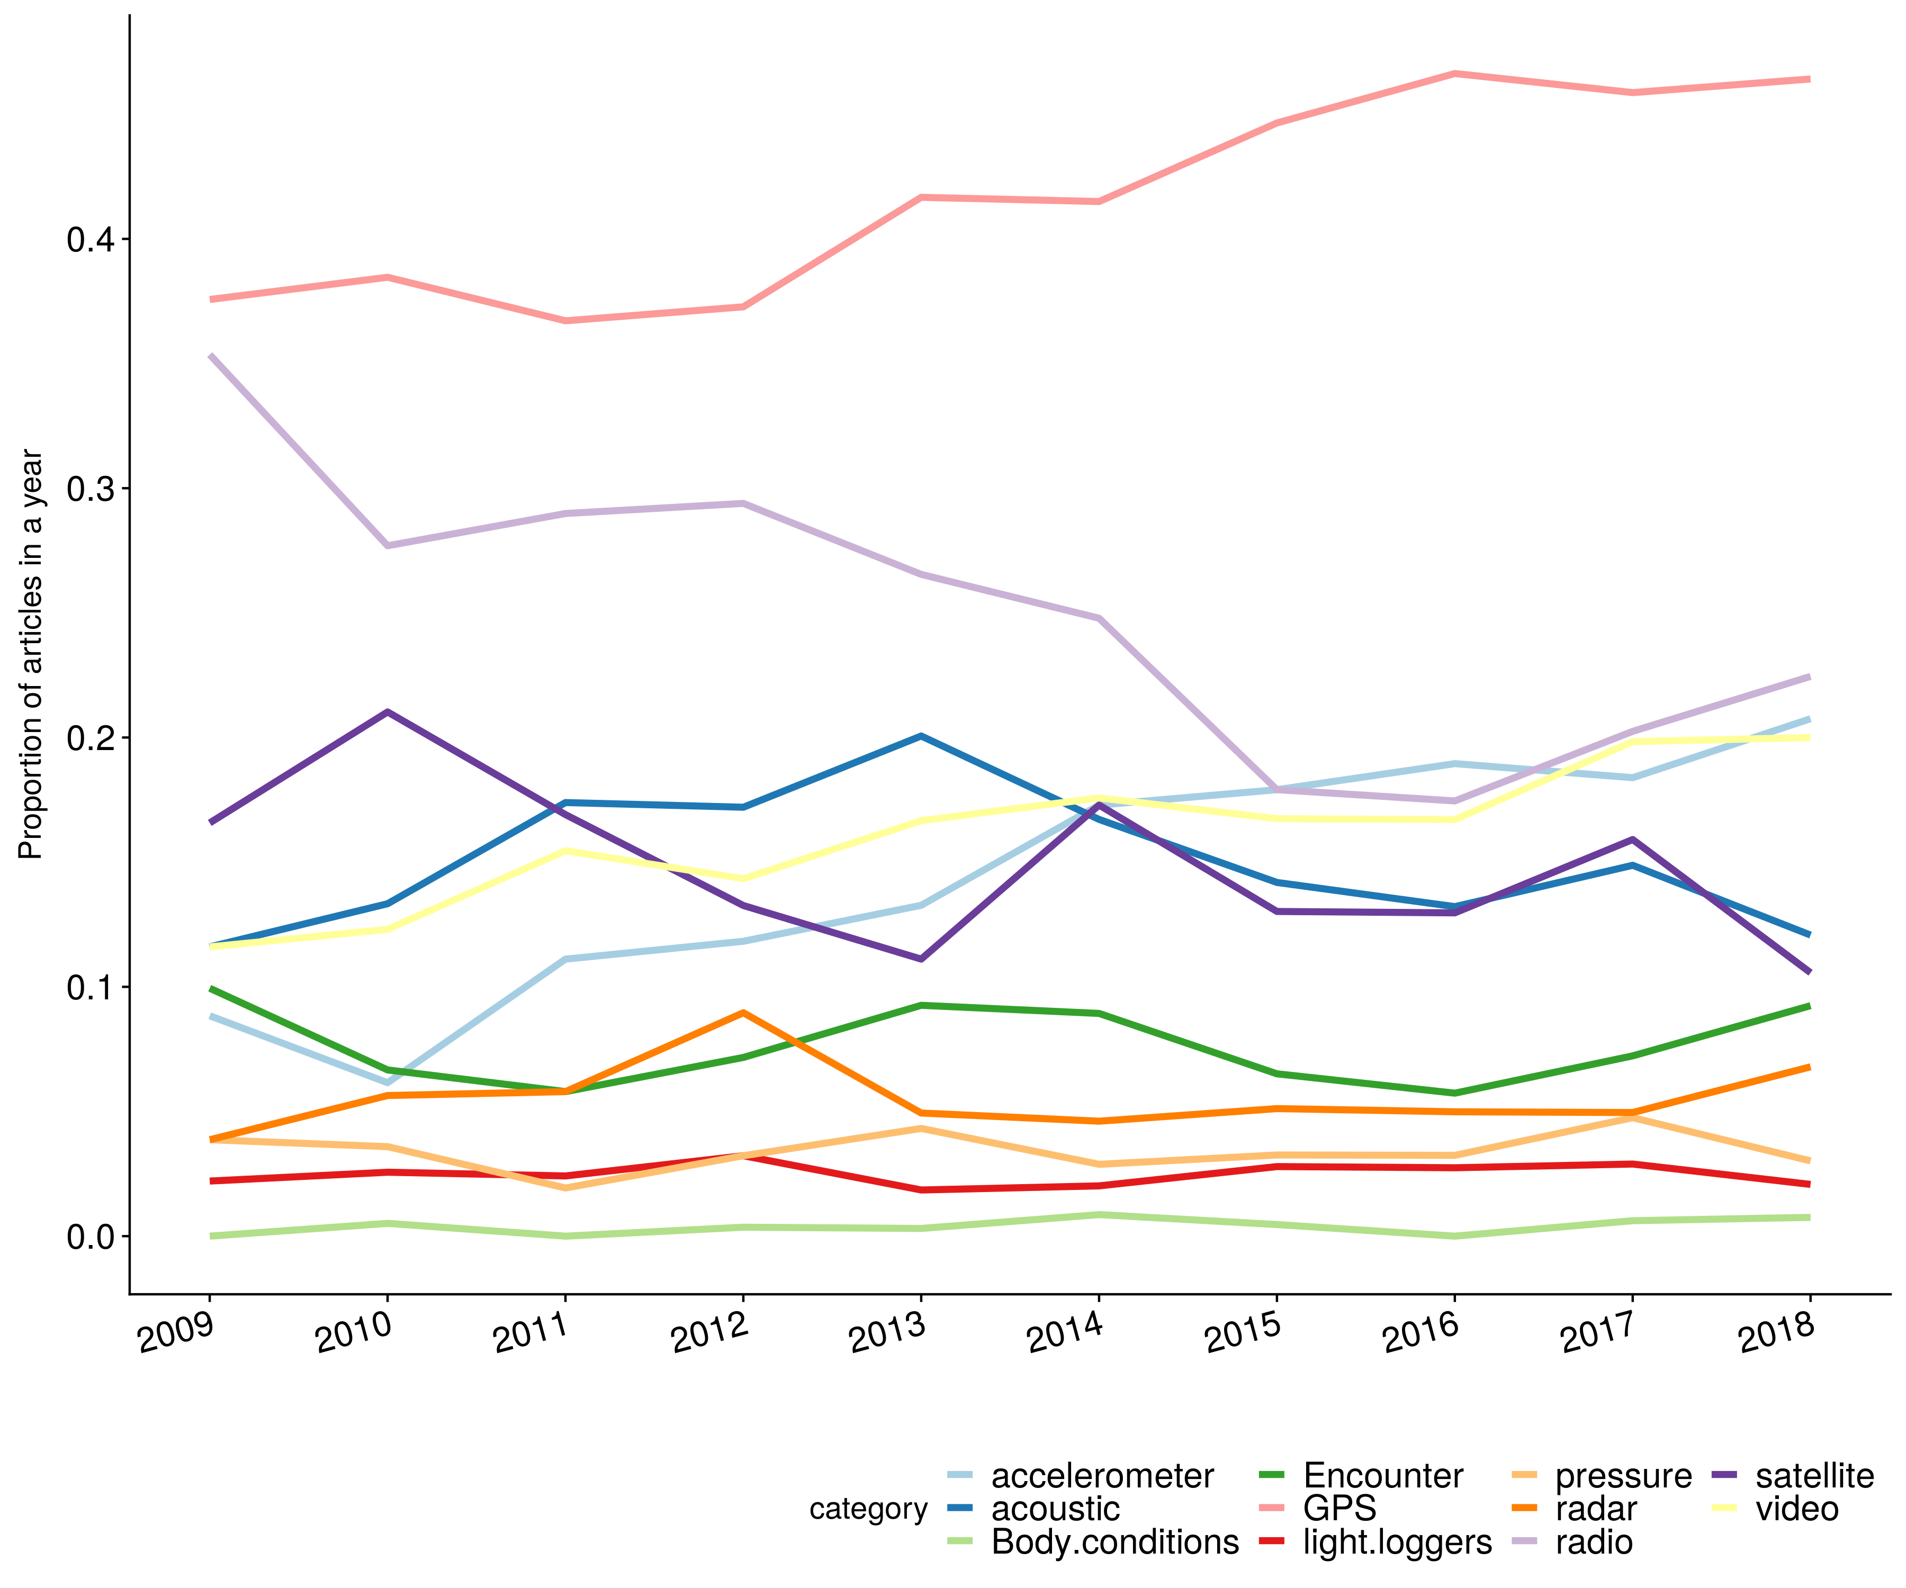{Fig.3. Proportion of papers of each year using each type of device}

The increasing volumes and diversity of movement data obtained through these tracking devices require appropriate software tools for data management, processing and analysis (Urbano et al. (2010), Joo et al. (2020)). We evaluated the use of 36 software (Supp.Mat) and found a marked growing trend in the use of R and a decreasing trend in the use of the other 5 most popular software (i.e. ArcGIS, Matlab, SPSS and SAS) (Fig. 4). In another study in the field of ecology, the same pattern in reported R usage was observed (Lai et al. (2019)). In both cases, the popularity of R ten years ago was very low ( $>10\%$ of the papers used it) and now the majority of articles have reported using it. At least for movement ecology, these findings could be an indication of a homogeneization process towards R. R does not only have more than 50 packages to process and analyze movement (Joo et al. (2020)), but it also offers a free and software environment to program and create new methods, share them and improve them, facilitating transparency, collaboration and reproducibility (Lowndes et al. (2017)). R also leverages all languages by allowing access to other languages internally (e.g. C, python, Fortran, etc.). While there is a possibility that other free and open software could eventually increase their popularity in movement ecology, the evidence shows that it will not occur in the foreseeable future (Fig. 4).

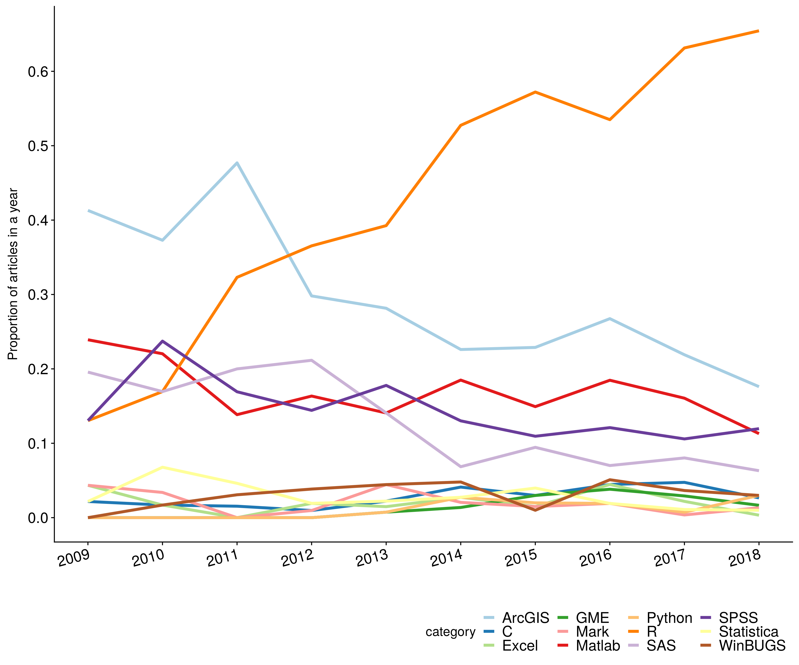{Fig.4. Proportion of papers of each year using each software (12 most mentioned software)}

In parallel with the development and improvement of tracking devices and software, a large literature of quantitative methods for the study of movement has been published, mostly on movement models (e.g. Patterson et al. (2008), Jonsen et al. (2013), Johnson et al. (2008)). We investigated the use of statistical movement-related methods in the movement ecology literature (see Supp. Mat. for methodological details). Most works (71%) used general statistical methods (i.e. with no explicit spatial or temporal component in its definition such as regression models) and less than a third of them (32%) used movement methods (i.e. methods developed for movement or spatiotemporal methods commonly applied to movement data). Researchers are not necessarily using movement-specific techniques to analyze movement. Actually, when accounting for movement, (non-movement) spatiotemporal, spatial, time series and social analysis, 57% of the papers used at least one method within these categories of them, which is still less than the use of general methods (71%). Actually, we found that the proportion of papers using any of these other types of methods is decreasing, and more papers are using methods that do not naturally account for time, space or movement (Fig. 5 and 6). The word cloud built from methods sections (Fig. S12) did not highlight any particular method except for “regression” (26% of the papers), unless we associate some words such as “mix” and “effect” (18% of the papers mention “mixed effect” or “mixed model” in their methods section), or “step” and “selection” (1% of the papers mention “step selection”). Only 4% of the methods sections mentioned “movement model”.

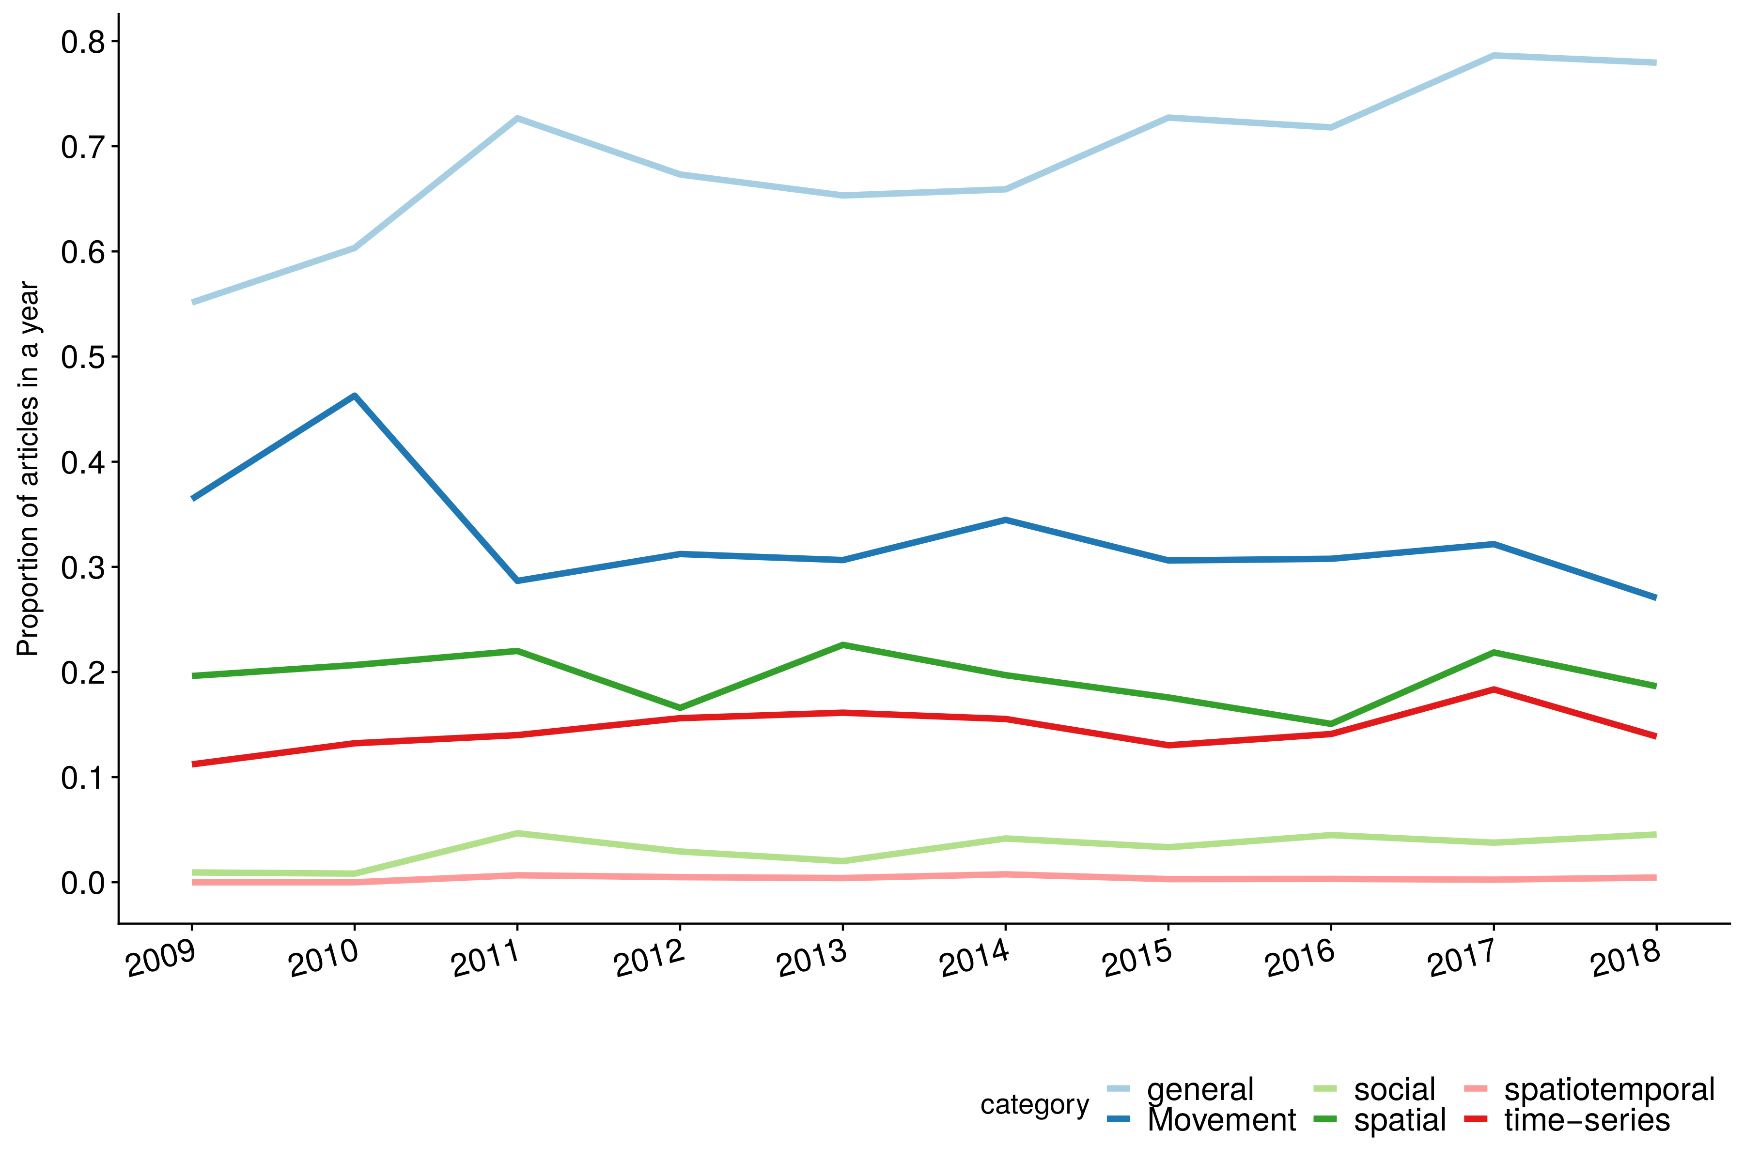{Fig.5. Proportion of papers of each year using each type of method}

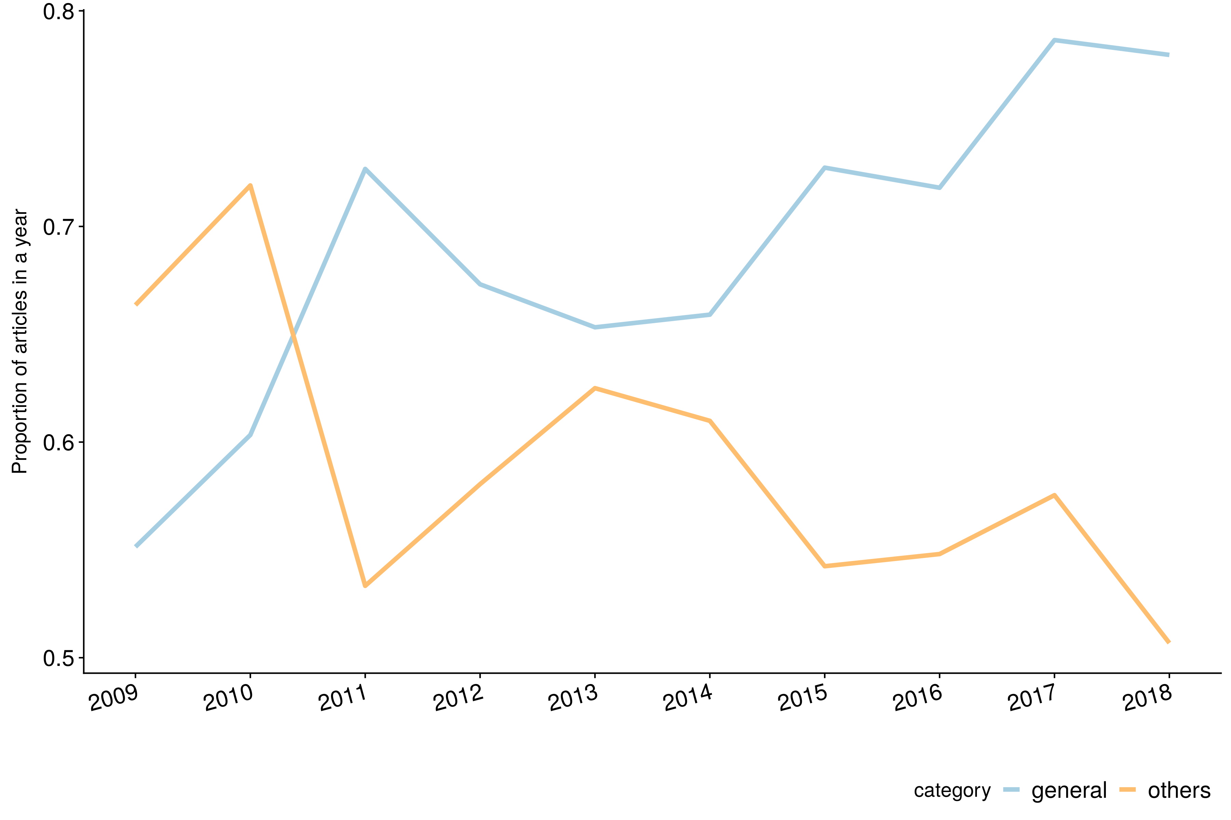{Fig.6. Proportion of papers of each year using general methods and others}

While the availability of movement data and software tools to handle it is increasing, and many methods have been developed to analyze it (see a summary list in Börger (2016)), they have not been adopted by the majority of the community yet. There may be works that do not require movement-specific methods (e.g. descriptive papers); however, as we intensify data collection and processing, the use of movement models – for a statistical representation of movement and for inference towards the population level – should increase accordingly. Movement is a complex process, and in most cases, statistically noisy, nonlinear and spatially and temporally correlated (Patterson et al. (2017)). Multidisciplinary work between ecologists and statisticians to “decomplexify” models (either making them more simple or useable for different datasets and situations) remains a challenge.

[Comment 7]: # (RJ: Do you think I should say something about machine learning? I could ramble about how people say it's going to be the "thing" now with all the data we are getting, but honestly up to now only 1% of methods sections have said "machine learning", "deep learning" or "big data" -- OK, they could use other words. I don't think it's that relevant now, and I don't think it's a good thing if people just turn into that and forget about movement modeling and trying to get mechanistic approaches to modeling movement. Hence, I've got things to say but I'm not sure that it's worth it for the paper. Thoughts?)

## Topics and research subjects in movement ecology

We investigated the research subjects addressed in movement ecology papers. For that matter, we analyzed the paper abstracts using a Latent Dirichlet Allocation (LDA) model (Blei, Ng, and Jordan (2003)) and identified 15 general topics from the abstracts (see Supp. Mat. for details). We fixed the number of topics to 15, as a reasonable value that would not be too large than we could not interpret them, or too small that the topics were too general (see discussion in Supp. Mat.). Within the LDA modeling framework, an abstract – or rather meaningful words from an abstract – is a mixture of all the latent topics (not known *a* *priori*), and the degree of association between the abstract and each topic is characterized by a parameter $γ$ that varies from 0 to 1. If a topic was not relevant at all for a given abstract, its $γ$ would approach zero, and it would approach one in the opposite case (the sum of all $γ$ s for an abstract is equal to 1). Each topic is defined as a mixture of all words and what distinguishes a topic from another is the relative frequency of each word (i.e. some words could be strongly related to a topic and barely appear in another). This relative frequency is represented in the word clouds of Figure 7, used for the interpretation of the topics: 1) Predator, 2) Wildlife habitat, 3) Social behavior, 4) Physical activity, 5) Data, 6) Models, 7) Fish movement, 8) Sex and dispersal, 9) Home range, 10) Marine foraging behavior, 11) Human motion, 12) Animal motion, 13) Tests, 14) Marine habitat and 15) Breeding and migration.

The three most addressed topics in the abstract (i.e. higher sum of $γ$ s) were models, data and social behavior. Since it is common practice to mention data and methods in abstracts, it is not surprising that both of them are recurrent topics. Furthermore, the models topic does not strictly refer to movement models; it encompasses any type of model (e.g. generalized linear model, model selection criterion or even schematical model) that could be used to study dynamics, patterns and populations (Fig. 7). A third place for social behavior is rather unexpected, but could be partly explained by the general interest in utilizing individual movement for understanding dynamics at the scale of populations.

[Comment 7+1]: # (RJ: Other ideas?)

{Fig.7. Word cloud for each topic. In each topic, the area occupied by each word is proportional to the proportion of papers that mention it. The color variation is respected throughout all topics.}

The fact that an abstract addresses a topic does not necessarily makes the topic a research subject for the paper. We considered to be certain that a topic was a research subject of a paper only if it had a $γ>0.75$ associated to the paper. Only 26% of the papers (2065) were associated to a topic with $γ>0.75$. Data, fish movement and human motion were the three main research subjects (12%, 10% and 10% of the papers with a research subject, respectively). The development of tracking technologies have resulted in a large production of scientific papers focused on the development and use of different sensors to study movement. Fish are the second most studied taxonomical group, only after mammals (Fig. S13). Fish movement addressed behavior, habitat, migration and spawning questions, mostly in freshwater but not exclusively (Fig. S12) and primarily using acoustic telemetry (Fig. S10). A large proportion of articles studying fish movement reflects the important role of this community in the production of movement ecology research. On the other hand, human motion studies focused on speed, distance, acceleration and overall performance in activities such as running, training, walking and playing (Fig. S12), also using GPS and accelerometers (Fig. S10); some of these studies concerned sport players. While fish movement has been an important research subject throughout the decade, human mobility has become one of the most studied areas only in the last years (Fig. S14). Studies of human mobility are relatively recent compared to animal movement and they have exponentially grown in number, as it is now easier to track humans with GPS tracking smartphones, geolocated internet posts and credit cards (Thums et al. (2018)). It is likely that this development in human mobility has greatly contributed to the rise of research on movement data in the last years (Fig. S14). Conversely, the study of animal motion (e.g. swim, flight, speed, acceleration) has been losing importance in the movement ecology literature (Fig. S14).

## The future of movement ecology

Movement ecology, in the last decade, has been strongly driven by tools availability (data, software, methods). Tracking data let us observe and follow movement, whether terrestrial, aerial or marine, and remote sensing data have enable insights on their environments (though see Hebblewhite and Haydon (2010) on dangers of divorcing biologists from the field). These observations, that were not possible to obtain in the past, have given rise to research questions about the ecology of the species, their physiology, and inspired methodological advances.

On the other hand, the MEF introduced by Nathan et al. (2008) has been recognized as a key and structural paradigm to study movement ecology (e.g. Doherty and Driscoll (2018), Pittman, Osbourn, and Semlitsch (2014), Morelle, Lehaire, and Lejeune (2014)). It was intended to set the stage of a unified theory of movement, thus being at the foundation of the research questions in the field: where is the animal going? how is the animal moving? what is the animal doing? why is the animal moving? (Williams et al. (2019)). As shown in this work, the link between movement and external factors has caught most of the attention from the community, and was the main studied component in all taxonomical groups (except humans). And while there have been advances on motion capacity and assessing the internal factors driving movement, and less in navigation, these components are still understudied.

There is, thus, a trade-off between data-driven movement ecology and ideas-driven movement ecology (mainly representedd by the MEF) (see an analogous discussion for physical sciences in Dyson (2012)). The topics identified here are a product of this trade-off. Some of them are inherently more data-driven (like the data topic itself), but most of them are a clear mixture of both ideas and data worlds.

These topics are also generally consistent with identified key questions in the movement ecology of marine megafauna (Hays et al. (2016)), most of which are relevant for movement ecology of organisms in general: anthropogenic effects (e.g. studied as human disturbance in habitats), prey and predation, the physiological context, the drivers of long-distance movement, social interactions, and mechanistic approaches to understand movement across species. Other questions in Hays et al. (2016) were not relevant in the literature topics but should be addressed more strongly in the future: the role of memory and innate behaviors in movement patterns, consistent with the poor number of studies in navigation; the role of megafauna in the ecosystem, maybe too specific to appear; climate change, which could have been a challenge up to now do to the length of the collected time series; and consequences of biologging on individuals and population, including the ethical responsibilities of researchers (Kays et al. (2015)). Finally, how movement can be used for conservation and management, another key question in Hays et al. (2016), appears in a few topics but not at the core of any of them. Except for human-centered movement studies (that are not fishers or hunters), conservation and management are the ultimate practical goal from studying movement. The lack of a conservation-specific topic may be a consequence of having papers (that are about different research subjects) referring to it as an indirect ultimate goal but only a few of them addressing how to effectively use movement for management (see Hays et al. (2019) for marine examples). Linking movement ecology to conservation and management seems to remain as a major challenge (Allen and Singh (2016), Ogburn et al. (2017), Lowerre-Barbieri et al. (2019)). Main issues behind this are disciplinary divides, insufficient data coverage, access or sharing, and concrete incorporation of movement into decision-making (Ogburn et al. (2017)).

Collaboration can enhance the development and use of tools for movement ecology, and allow systematic and simultaneous global tracking of aquatic, terrestrial and aerial species (Lowerre-Barbieri et al. (2019)). This should include working with human mobility scientists, who have built on animal movement research and are now growing in number, data and development of tracking devices, data management tools and methods for data analysis (Thums et al. (2018)).

The development of open software tools seem promising (Joo et al. (2020)), and, as the amount of tracking data and tracked species is increasing (Thums et al. (2018), Kays et al. (2015) and this work), we should work on the development of a culture of data sharing (Ogburn et al. (2017), Vision (2010), Vines et al. (2013)), data standardization and use of repositories (Urbano et al. (2010), Campbell et al. (2016), Harcourt et al. (2019)). The choice and use of statistical methods requires strong collaboration between ecologists and statisticians. Furthermore, this collaboration should start in the study design, so that the choice of tracking devices, sample size and methods for analysis, can be a direct consequence of the research questions (and field/financial constraints) (Williams et al. (2019)). A closer collaboration would also allow statisticians to rise to the challenge of accommodating models to the questions and systems under study.

As the technology in movement continues to rise, it is critical that the ideas-driven and data-driven trade-off remains. Ideas and theories should continue to drive science, and be contradicted or confirmed by empirical studies. Likewise, empirical findings could be interpreted in the light of established knowledge in the field.

## Acknowledgements [So I don’t forget to thank people]

* Susana Clusella-Trullas, for fruitful exchanges about internal states and physiology.
* Trey Shelton, from UF library, for helping with APIs and TDM rights.
* Luis Cajachahua Espinoza, for help with scrapping possibilities at the first stages of exploratory analysis.

## Authors’ contributions [I will be adding stuff but feel free to add or edit]

* RJ conceived the ideas of the review and designed the study
* RJ and SP worked on the search keywords for mov-eco papers
* RJ, SP and MEB worked on codes to clean the results from WoS
* RJ and SP downloaded the papers and dealt with TDM rights
* RJ wrote the codes to extract material and method sections
* RJ, TAC, MEB, SP and MB lead the dictionaries and checked their precision (quality control)
* RJ, MEB and MB wrote the codes to analyze the papers with the dictionaries
* SP and MEB implemented the codes for identification of species and classification in taxonomical groups
* RJ and VR implemented the LDA modeling approach
* RJ and MEB produced the figures for the manuscript
* RJ, SP, TAC, MEB and MB worked on the questions of the survey and MEB implemented it in an online platform
* RJ analyzed the results of the survey
* RJ and MB worked on the outline of the manuscript
* RJ, SP, MB, TAC, MB and SCP actively participated in discussions about the outcomes of this work
* Everybody wrote something?
* There will be something to say about a Zenodo repository
* MEB gave coding support in different stages

Allan, Blake M., Dale G. Nimmo, Daniel Ierodiaconou, Jeremy VanDerWal, Lian Pin Koh, and Euan G. Ritchie. 2018. “Futurecasting Ecological Research: The Rise of Technoecology.” *Ecosphere* 9 (5): e02163. <https://doi.org/10.1002/ecs2.2163>.

Allen, Andrew M., and Navinder J. Singh. 2016. “Linking Movement Ecology with Wildlife Management and Conservation.” *Frontiers in Ecology and Evolution* 3. <https://doi.org/10.3389/fevo.2015.00155>.

Blei, David M., Andrew Y. Ng, and Michael I. Jordan. 2003. “Latent Dirichlet Allocation.” *Journal of Machine Learning Research* 3 (Jan): 993–1022. <http://jmlr.csail.mit.edu/papers/v3/blei03a.html>.

Börger, Luca. 2016. “EDITORIAL: Stuck in Motion? Reconnecting Questions and Tools in Movement Ecology.” *Journal of Animal Ecology* 85 (1): 5–10. <https://doi.org/10.1111/1365-2656.12464>.

Campbell, Hamish A., Ferdi Urbano, Sarah Davidson, Holger Dettki, and Francesca Cagnacci. 2016. “A Plea for Standards in Reporting Data Collected by Animal-Borne Electronic Devices.” *Animal Biotelemetry* 4 (1): 1. <https://doi.org/10.1186/s40317-015-0096-x>.

Doherty, Tim S., and Don A. Driscoll. 2018. “Coupling Movement and Landscape Ecology for Animal Conservation in Production Landscapes.” *Proceedings of the Royal Society B: Biological Sciences* 285 (1870): 20172272. <https://doi.org/10.1098/rspb.2017.2272>.

Dyson, Freeman J. 2012. “Is Science Mostly Driven by Ideas or by Tools?” *Science* 338 (6113): 1426–7. <https://doi.org/10.1126/science.1232773>.

Hansson, Lars-Anders, and Susanne Akesson. 2014. *Animal Movement Across Scales*. Oxford university press.

Harcourt, Rob, Ana Micaela Martins Sequeira, Xuelei Zhang, Fabien Rouquet, Kosei Komatsu, Michelle Heupel, Clive R. McMahon, et al. 2019. “Animal-Borne Telemetry : An Integral Component of the Ocean Observing Toolkit,” June. <https://doi.org/https://doi.org/10.3389/fmars.2019.00326>.

Hays, Graeme C., Helen Bailey, Steven J. Bograd, W. Don Bowen, Claudio Campagna, Ruth H. Carmichael, Paolo Casale, et al. 2019. “Translating Marine Animal Tracking Data into Conservation Policy and Management.” *Trends in Ecology & Evolution* 34 (5): 459–73. <https://doi.org/10.1016/j.tree.2019.01.009>.

Hays, Graeme C., Luciana C. Ferreira, Ana M. M. Sequeira, Mark G. Meekan, Carlos M. Duarte, Helen Bailey, Fred Bailleul, et al. 2016. “Key Questions in Marine Megafauna Movement Ecology.” *Trends in Ecology & Evolution* 31 (6): 463–75. <https://doi.org/10.1016/j.tree.2016.02.015>.

Hebblewhite, Mark, and Daniel T. Haydon. 2010. “Distinguishing Technology from Biology: A Critical Review of the Use of GPS Telemetry Data in Ecology.” *Philosophical Transactions of the Royal Society B: Biological Sciences* 365 (1550): 2303–12. <https://doi.org/10.1098/rstb.2010.0087>.

Holyoak, Marcel, Renato Casagrandi, Ran Nathan, Eloy Revilla, and Orr Spiegel. 2008. “Trends and missing parts in the study of movement ecology.” *Proceedings of the National Academy of Sciences of the United States of America* 105 (49): 19060–5. <https://doi.org/10.1073/pnas.0800483105>.

Johnson, Devin S, Joshua M London, Mary-Anne Lea, and John W Durban. 2008. “Continuous-Time Correlated Random Walk Model for Animal Telemetry Data.” *Ecology* 89 (5): 1208–15. <https://doi.org/10.1890/10-1922.1>.

Jonsen, I. D., M. Basson, S. Bestley, M. V. Bravington, T. A. Patterson, M. W. Pedersen, R. Thomson, U. H. Thygesen, and S. J. Wotherspoon. 2013. “State-space models for bio-loggers: A methodological road map.” *Deep-Sea Research Part II* 88–89: 34–46. <https://doi.org/10.1016/j.dsr2.2012.07.008>.

Joo, Rocio, Matthew E. Boone, Thomas A. Clay, Samantha C. Patrick, Susana Clusella-Trullas, and Mathieu Basille. 2020. “Navigating Through the R Packages for Movement.” *Journal of Animal Ecology. Accepted*.

Kays, Roland, Margaret C. Crofoot, Walter Jetz, and Martin Wikelski. 2015. “Terrestrial Animal Tracking as an Eye on Life and Planet.” *Science* 348 (6240): aaa2478.

Lai, Jiangshan, Christopher J. Lortie, Robert A. Muenchen, Jian Yang, and Keping Ma. 2019. “Evaluating the Popularity of R in Ecology.” *Ecosphere* 10 (1): e02567. <https://doi.org/10.1002/ecs2.2567>.

Lowerre-Barbieri, Susan K., Roland Kays, James T. Thorson, and Martin Wikelski. 2019. “The Ocean’s Movescape: Fisheries Management in the Bio-Logging Decade (2018–2028).” *ICES Journal of Marine Science* 76 (2): 477–88. <https://doi.org/10.1093/icesjms/fsy211>.

Lowndes, Julia S. Stewart, Benjamin D. Best, Courtney Scarborough, Jamie C. Afflerbach, Melanie R. Frazier, Casey C. O’Hara, Ning Jiang, and Benjamin S. Halpern. 2017. “Our Path to Better Science in Less Time Using Open Data Science Tools.” *Nature Ecology & Evolution* 1 (6): 0160.

Morelle, Kevin, François Lehaire, and Philippe Lejeune. 2014. “Is Wild Boar Heading Towards Movement Ecology? A Review of Trends and Gaps.” *Wildlife Biology* 20 (4): 196–205. <https://doi.org/10.2981/wlb.00017>.

Nathan, R, W M Getz, E Revilla, M Holyoak, R Kadmon, D Saltz, and P E Smouse. 2008. “A movement ecology paradigm for unifying organismal movement research.” *PNAS* 105 (49): 19052–9.

Ogburn, Matthew B., Autumn-Lynn Harrison, Frederick G. Whoriskey, Steven J. Cooke, Joanna E. Mills Flemming, and Leigh G. Torres. 2017. “Addressing Challenges in the Application of Animal Movement Ecology to Aquatic Conservation and Management.” *Frontiers in Marine Science* 4. <https://doi.org/10.3389/fmars.2017.00070>.

Patterson, T A, L Thomas, C Wilcox, O Ovaskainen, and J Matthiopoulos. 2008. “State-space models of individual animal movement.” *Trends in Ecology and Evolution* 23 (2): 87–94. <https://doi.org/doi:10.1016/j.tree.2007.10.009>.

Patterson, Toby A, Alison Parton, Roland Langrock, Paul G Blackwell, Len Thomas, and Ruth King. 2017. “Statistical Modelling of Individual Animal Movement: An Overview of Key Methods and a Discussion of Practical Challenges.” *AStA Advances in Statistical Analysis*. <https://doi.org/10.1007/s10182-017-0302-7>.

Pittman, Shannon E., Michael S. Osbourn, and Raymond D. Semlitsch. 2014. “Movement Ecology of Amphibians: A Missing Component for Understanding Population Declines.” *Biological Conservation* 169 (January): 44–53. <https://doi.org/10.1016/j.biocon.2013.10.020>.

Thums, Michele, Juan Fernández-Gracia, Ana M. M. Sequeira, Víctor M. Eguíluz, Carlos M. Duarte, and Mark G. Meekan. 2018. “How Big Data Fast Tracked Human Mobility Research and the Lessons for Animal Movement Ecology.” *Frontiers in Marine Science* 5. <https://doi.org/10.3389/fmars.2018.00021>.

Urbano, F, F Cagnacci, Clément Calenge, H Dettki, A Cameron, and M Neteler. 2010. “Wildlife Tracking Data Management: A New Vision.” *Philosophical Transactions of the Royal Society of London, Series B: Biological Sciences* 365: 2177–85.

Vines, Timothy H., Rose L. Andrew, Dan G. Bock, Michelle T. Franklin, Kimberly J. Gilbert, Nolan C. Kane, Jean-Sébastien Moore, et al. 2013. “Mandated Data Archiving Greatly Improves Access to Research Data.” *The FASEB Journal* 27 (4): 1304–8. <https://doi.org/10.1096/fj.12-218164>.

Vision, Todd J. 2010. “Open Data and the Social Contract of Scientific Publishing.” *BioScience* 60 (5): 330–31. <https://doi.org/10.1525/bio.2010.60.5.2>.

Williams, Hannah J., Lucy A. Taylor, Simon Benhamou, Allert I. Bijleveld, Thomas A. Clay, Sophie de Grissac, Urška Demšar, et al. 2019. “Optimizing the Use of Biologgers for Movement Ecology Research.” *Journal of Animal Ecology* 0 (0). <https://doi.org/10.1111/1365-2656.13094>.